Children and Their Safety are Important at Chestnut Hill UMC
We rejoice that as a church we are able to offer carefully planned, age appropriate care and activities for our children and youth.
Today, children ages 6 and above will stay in the sanctuary for worship.
The Nursery for infants up to age 6 is located in Classroom 101 (exit through the right side door at the front of the sanctuary, pass through “the Commons,” go through the double doors to the Education Building and follow the hallway to the
Nursery at the end of the hall on the left).

DIRECTORY OF CHESTNUT HILL UNITED METHODIST CHURCH
 | Sharma Lewis | Richmond Area Resident Bishop
 | Scott Davis | Lynchburg District Superintendent
 | Liz Ecklund | Minister
 | Vernie Barrow | Minister Emeritus
 | Monica Campbell | Administrative Assistant
 | Heather Wilson | Director of Music Ministry
 | Judy Martin | Bookkeeper
 | Judy Robertson | Lay Leader
 | Erin Ecklund | Nursery Supervisor


Chestnut Hill
United Methodist Church

Making disciples of Jesus Christ
for the transformation of the world.
You are welcome at Chestnut Hill UMC.

4660 Fort Avenue ~ Lynchburg, Virginia 24502
Church: 434-239-8423
Pastor’s Cell: 434-258-2934; Pastor’s Home: 434-319-5646
Email Pastor Liz: Pastorliz@aol.com
chestnuthillumc@comcast.net ~ on the web at chestnuthillumc.net
Find us on Facebook: Chestnut Hill United Methodist Church
Chestnut Hill United Methodist Church
10:30 a.m. ~ November 24, 2019 ~ Christ the King Sunday/Thanksgiving Sunday
Our ministry vision for the Virginia Annual Conference is “to be disciples of Jesus Christ who are lifelong learners, who influence others to serve.”
Welcome! Join us in worshiping God!
Welcome and Ministry Announcements
Welcome in the name of Christ our Lord. Please register your attendance,
printing your name, address, phone, and email, when the pew pad is passed to you.
Thank you for silencing cell phones as we gather to worship God.
Invocation
Prelude “Bach Prelude” J.S. Bach
Call to Worship
Let all who seek the presence of the Lord come together!
Lord, come into our lives and touch our hearts.
We seek God's guidance in all we would do or say.
Lord, come into our lives and open our hearts so that we may know You.
God so loved us that we were sent the Christ to give us eternal life.
Blessed be the name of the Lord!
*Singing Our Faith # 103 “Immortal, Invisible, God Only Wise”
Morning Prayer
O God of Eternity, we stand with the courage of those who insisted, even in perilous times, that not even the most powerful rulers of this earth hold our eternal destiny in their hands. We are secure in Christ, whose reign is just, whose power is endless, and whose love is unfathomable. God of Eternity, we join the chorus of saints who continue to declare that Christ is our King. Amen.
Choral Anthem “A Psalm of Thanks” Fettke
Prayer for Illumination Heather Wilson
Let the words of our mouths, and the meditations of our hearts be acceptable in your sight, O Lord, our Rock and our Redeemer. Amen.

New Testament Lesson Colossians 1:11-20 (MSG) Heather Wilson
Gospel Lesson Luke 23:33-43 (MSG) Heather Wilson
The Word of God for the people of God.
Thanks be to God.
Singing Our Faith # 131 “We Gather Together”
The Good News “Gifts”
The Giving of God’s Tithes and Our Gifts
Prayer of Thanksgiving
Offertory “Give Thanks” arr. Hayes
*Doxology # 95 Praise God from whom all blessings flow; praise him, all
Creatures here below; praise him above, ye heavenly host; praise Father, Son, and Holy Ghost. Amen.
The Prayers of the People
The Lord’s Prayer
Our Father, who art in heaven, hallowed be thy name. Thy kingdom come,
Thy will be done on earth as it is in heaven. Give us this day our daily bread and forgive us our trespasses, as we forgive those who trespass against us. And lead us not into temptation, but deliver us from evil. For thine is the kingdom, and the power, and the glory, forever. Amen.
*Singing Our Faith # 327 “Crown Him with Many Crowns”
*Blessing and Dismissal
*Postlude
Scatter to Serve God & Neighbor
Welcome to all! We gather to praise God for the innumerable blessings given to us and to grow deeper in the Spirit. Joyfully, let us lift our hearts to God.

**This Week’s Calendar**

Tuesday, 11/26 | 9:00 a.m. | Prayer Group
Wednesday, 11/27 | 6:30 p.m. | Cantata Rehearsal @ Timberlake UMC
Thursday, 11/28 |  | Happy Thanksgiving~Church Office Closed
Friday, 11/29 |  | Church Office Closed
Saturday, 11/30 | 10:00 a.m. | Decorating of Church  Helpers greatly appreciated. For more information contact Judy Robertson.
** Looking Ahead on the Calendar **
Sunday, 12/8 | 11:45 a.m. | Chestnut Hill UMC Annual Christmas Lunch  RSVP forms have been included in today’s bulletin. Place in basket in the Commons.
Saturday, 12/14 | 10:00 a.m. | United Methodist Women Lunch/Baskets  Put your cookies (prefer homemade), 6-8, in a Ziplock bag for the fruit baskets. Please have your Cookies at the Church by 10:30 am. Don't forget to bring a Dish for Lunch.
Sunday, 12/15 |  | Christmas Cantata “Love Made A Way” with Timberlake United Methodist Church choir.  Two (2) performances: 8:30 a.m. & 2:00 p.m.  All are invited!
Monday, 12/16 | 12:00 PM | Barrow Sunday School Christmas Luncheon
Mitten Tree Trunk
The Mitten Tree Trunk is now up for your donations thru the month of December. You may bring mittens, gloves, hats, etc. Place them in the trunk that is provided in the Commons.
Read Ahead
December 1, 2019 - 1st Sunday of Advent. The Scriptures are Matthew 24:36-44 & Psalm 122. The sermon text is Isaiah 2:1-5 and the message is “Rushing”.

In the Grocery Cart This Month
For NOVEMBER: We will collect food for Thanksgiving: “cranberry sauce, corn, green beans, yams; jars of gravy, boxed stuffing, and boxed cornbread mix. In the Hygiene room we are in need of body wash for men and women and body lotion. Please feel free to donate any other hygiene products.” For DECEMBER: “body wash, body lotion, deodorant, baby wipes, toothpaste”. Place donations in the grocery cart, located in the Commons. **NOTE: Please put all liquids in the box provided. Tape down all flip top bottles.

2019 Christmas Angel Tree Program
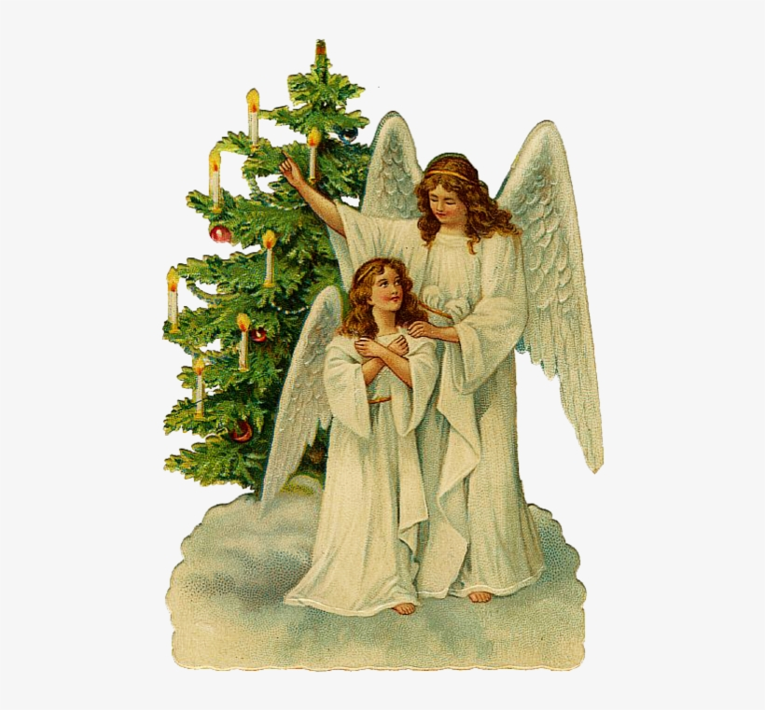
If you are giving money rather than shopping, please turn it in to church by Sunday, December 1. Then all money will be turned over to Humankind on Wednesday, December 4, so that their staff can shop for your child. They will return the gifts to us on December 13 so that the women of the church can wrap/gift bag them at the UMW luncheon on December 14.
IMPORTANT: If you are SHOPPING for your angel, have all gifts returned to the church NO LATER than Thursday, December 12th!
Stewardship Thought
The Colossians passage challenges all generations of Christ's people to give power where it belongs - to God alone. The life of Christ teaches us that this is not about bowing to altars in sanctuaries or even a total focus of our lives upon the worship of God - unless that is enacted by challenging the powers that exist in our lives in general. It is not mostly personal sin that oppresses, starves, and causes other suffering to vulnerable people around the world. It is the global economic, political, and military powers of our day. It is not those who say "Lord, Lord" who will enter the reign of God but those who care for those in need and challenge all those who cause pain and injustice to others. It will take faith to believe that we may overcome these massive powers - faith that takes heart from the Christ who walked toward them with courage and entered into suffering.

**This Week’s Calendar**

Tuesday, 11/26 | 9:00 a.m. | Prayer Group
Wednesday, 11/27 | 6:30 p.m. | Cantata Rehearsal @ Timberlake UMC
Thursday, 11/28 |  | Happy Thanksgiving~Church Office Closed
Friday, 11/29 |  | Church Office Closed
Saturday, 11/30 | 10:00 a.m. | Decorating of Church  Helpers greatly appreciated. For more information contact Judy Robertson.
** Looking Ahead on the Calendar **
Sunday, 12/8 | 11:45 a.m. | Chestnut Hill UMC Annual Christmas Lunch  RSVP forms have been included in today’s bulletin. Place in basket in the Commons.
Saturday, 12/14 | 10:00 a.m. | United Methodist Women Lunch/Baskets  Put your cookies (prefer homemade), 6-8, in a Ziplock bag for the fruit baskets. Please have your Cookies at the Church by 10:30 am. Don't forget to bring a Dish for Lunch.
Sunday, 12/15 |  | Christmas Cantata “Love Made A Way” with Timberlake United Methodist Church choir.  Two (2) performances: 8:30 a.m. & 2:00 p.m.  All are invited!
Monday, 12/16 | 12:00 PM | Barrow Sunday School Christmas Luncheon
Mitten Tree Trunk
The Mitten Tree Trunk is now up for your donations thru the month of December. You may bring mittens, gloves, hats, etc. Place them in the trunk that is provided in the Commons.
Read Ahead
December 1, 2019 - 1st Sunday of Advent. The Scriptures are Matthew 24:36-44 & Psalm 122. The sermon text is Isaiah 2:1-5 and the message is “Rushing”.

In the Grocery Cart This Month
For NOVEMBER: We will collect food for Thanksgiving: “cranberry sauce, corn, green beans, yams; jars of gravy, boxed stuffing, and boxed cornbread mix. In the Hygiene room we are in need of body wash for men and women and body lotion. Please feel free to donate any other hygiene products.” For DECEMBER: “body wash, body lotion, deodorant, baby wipes, toothpaste”. Place donations in the grocery cart, located in the Commons. **NOTE: Please put all liquids in the box provided. Tape down all flip top bottles.

2019 Christmas Angel Tree Program
If you are giving money rather than shopping, please turn it in to church by Sunday, December 1. Then all money will be turned over to Humankind on Wednesday, December 4, so that their staff can shop for your child. They will return the gifts to us on December 13 so that the women of the church can wrap/gift bag them at the UMW luncheon on December 14.
IMPORTANT: If you are SHOPPING for your angel, have all gifts returned to the church NO LATER than Thursday, December 12th!
Stewardship Thought
The Colossians passage challenges all generations of Christ's people to give power where it belongs - to God alone. The life of Christ teaches us that this is not about bowing to altars in sanctuaries or even a total focus of our lives upon the worship of God - unless that is enacted by challenging the powers that exist in our lives in general. It is not mostly personal sin that oppresses, starves, and causes other suffering to vulnerable people around the world. It is the global economic, political, and military powers of our day. It is not those who say "Lord, Lord" who will enter the reign of God but those who care for those in need and challenge all those who cause pain and injustice to others. It will take faith to believe that we may overcome these massive powers - faith that takes heart from the Christ who walked toward them with courage and entered into suffering.

